<https://www.flickr.com/photos/bz3rk/2677934556>

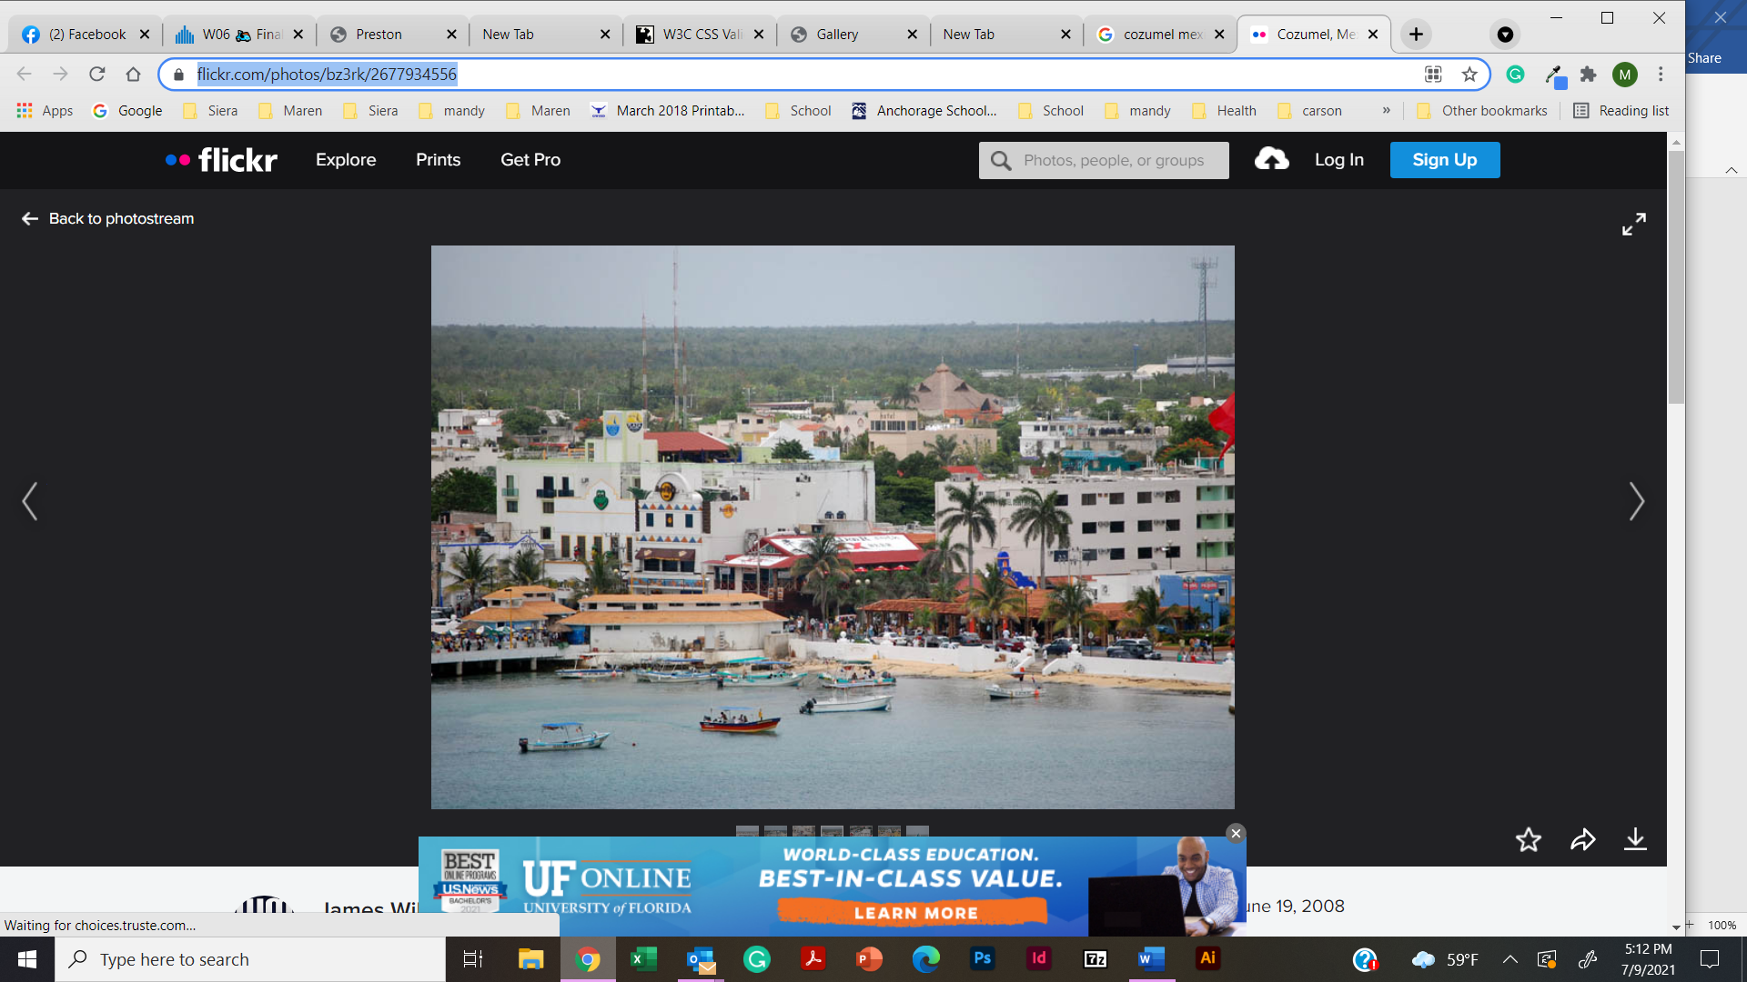

<https://www.flickr.com/photos/cseeman/23929348898/in/photostream/>

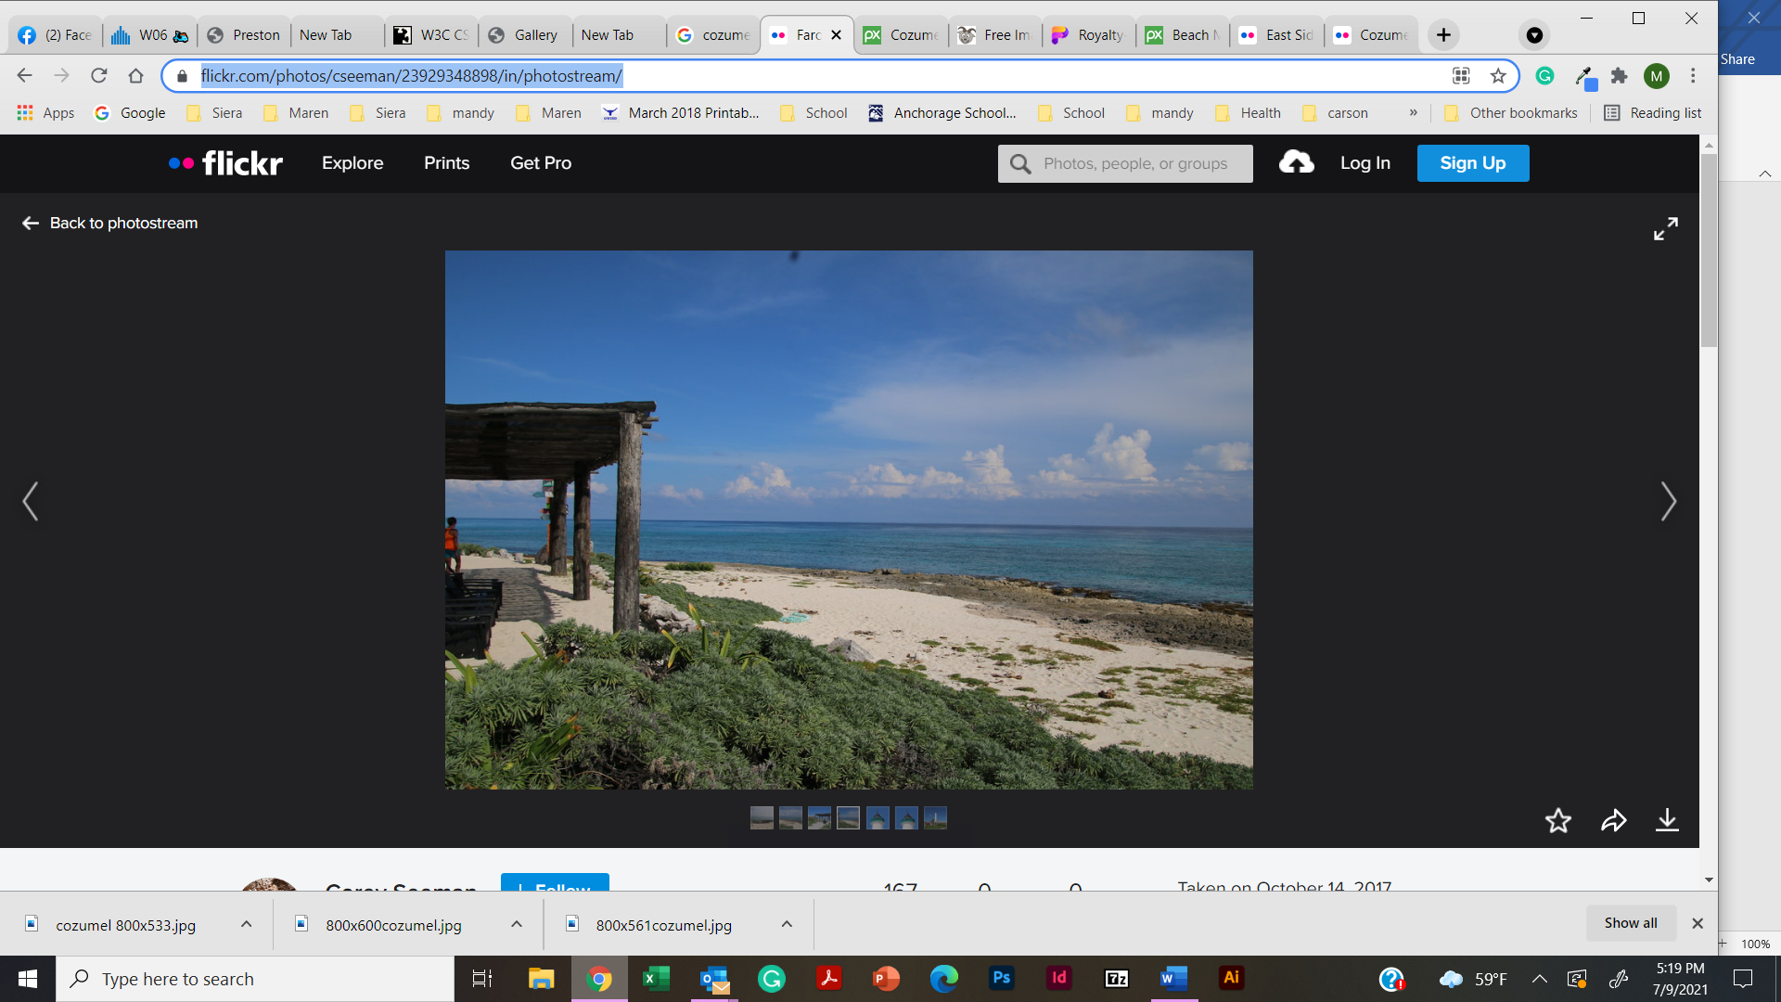

<https://upload.wikimedia.org/wikipedia/commons/thumb/d/dd/Palancar_beach_Cozumel_Mexico_%2821400947621%29.jpg/1024px-Palancar_beach_Cozumel_Mexico_%2821400947621%29.jpg>

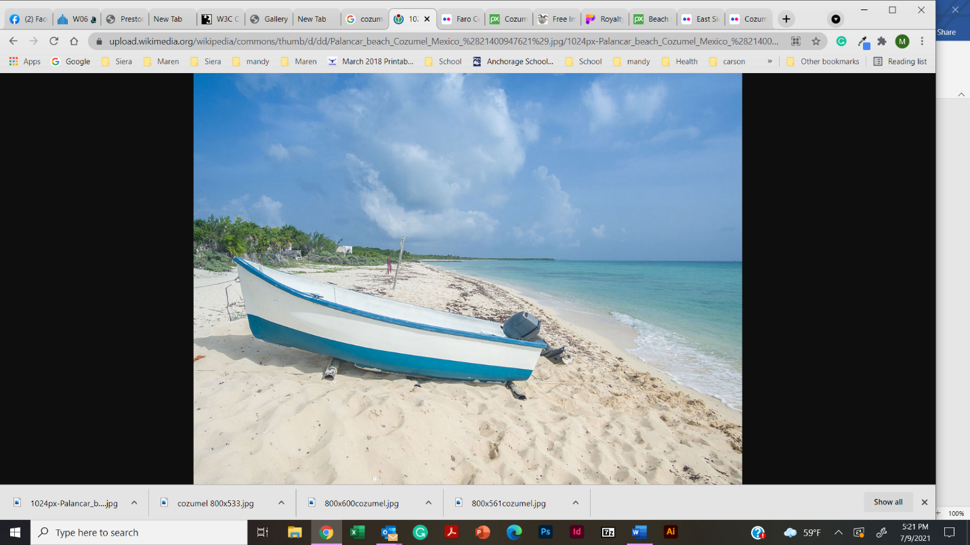

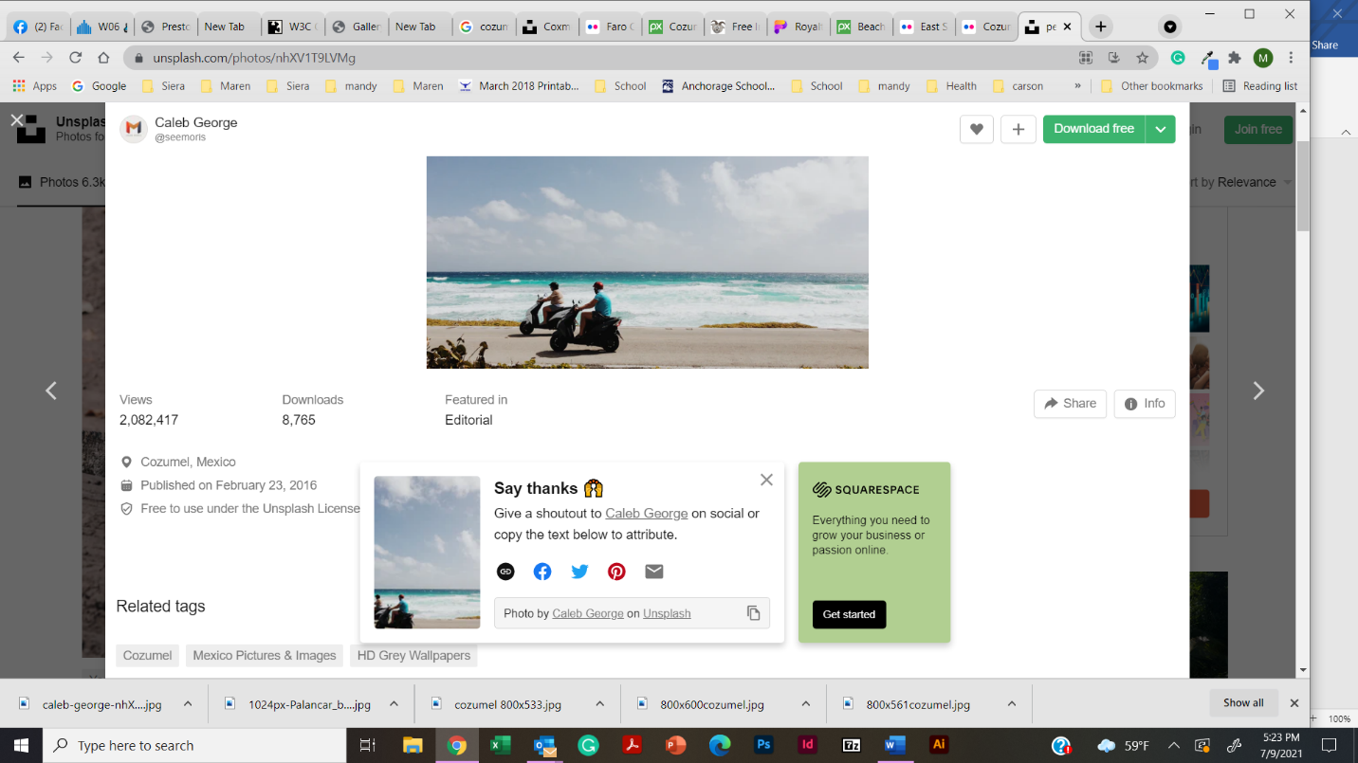

<https://unsplash.com/photos/nhXV1T9LVMg>

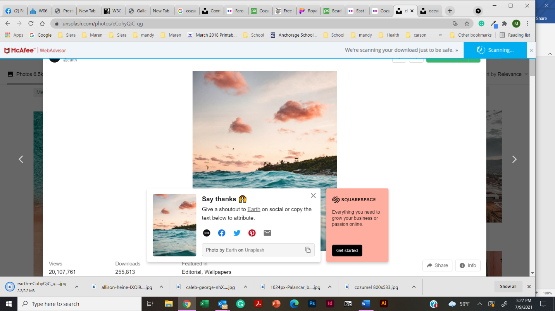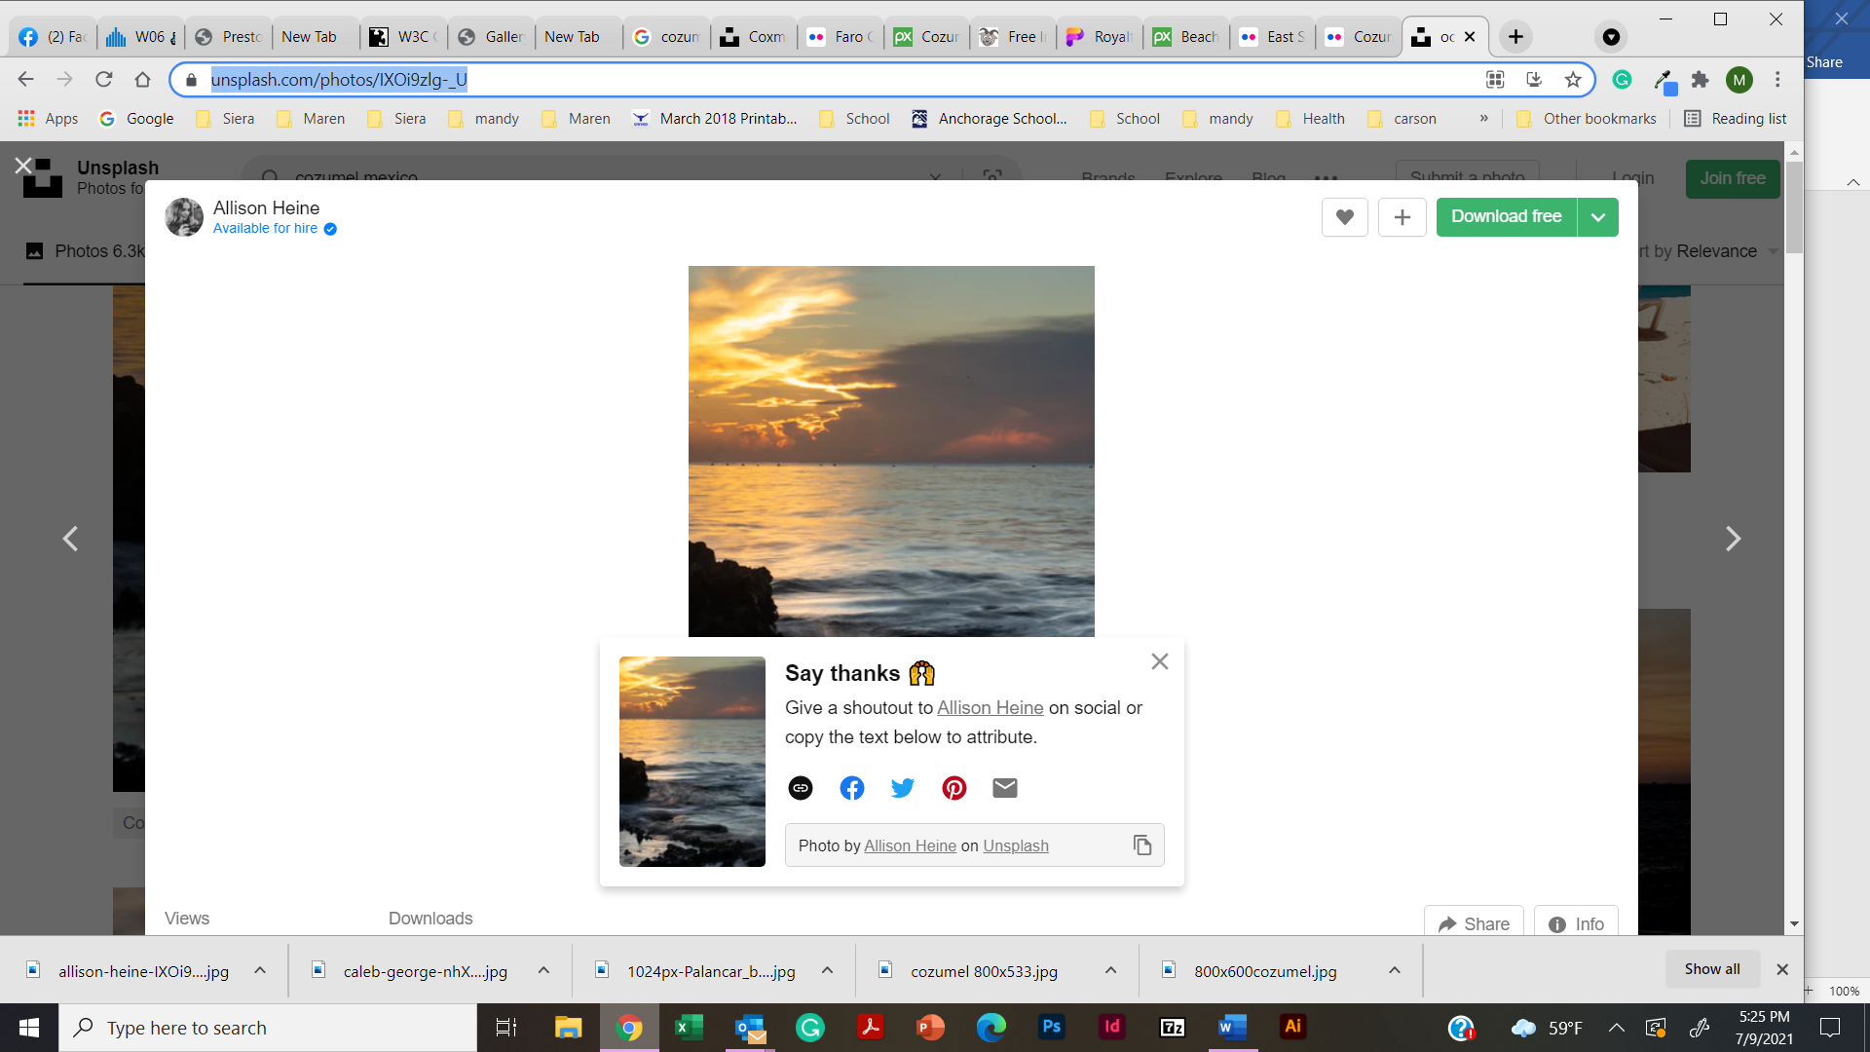<https://unsplash.com/photos/IXOi9zlg-_U>

[](https://unsplash.com/photos/IXOi9zlg-_U)

<https://unsplash.com/photos/eCohyQiC_qg>

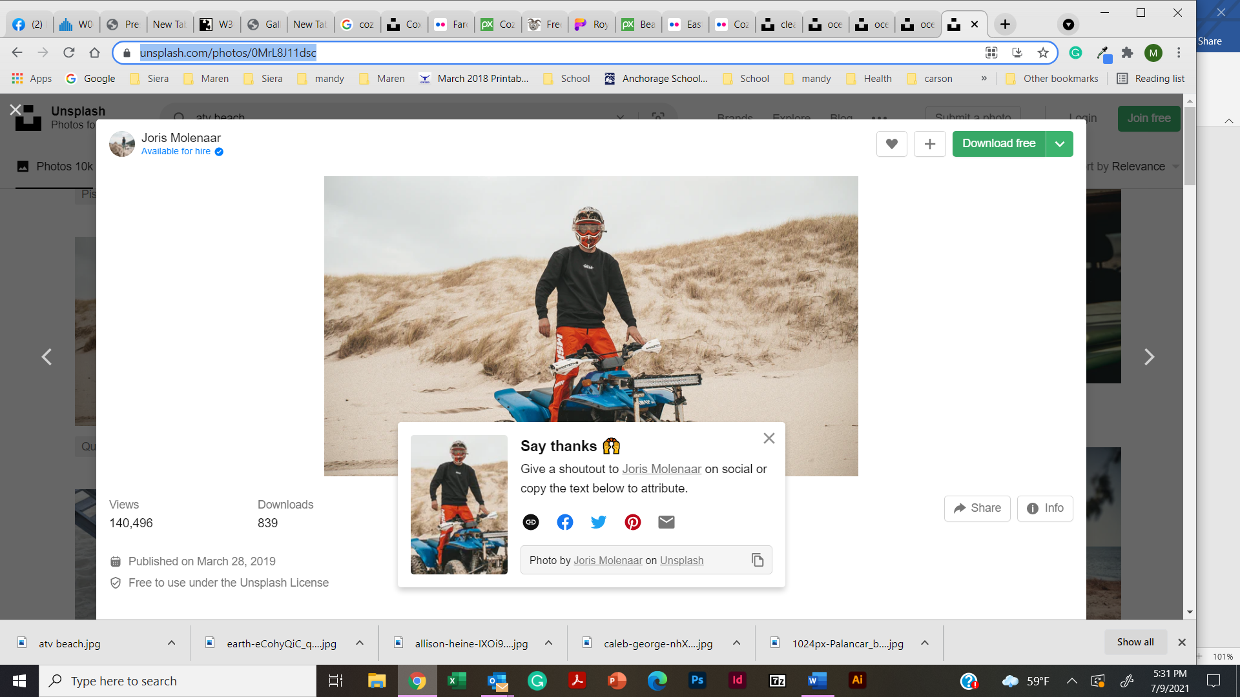

<https://unsplash.com/photos/0MrL8J11dsc>

https://unsplash.com/photos/ryRlBohnKGI

